**Flashing provider configuration BKM**

(BMC Flashing, CPLD Flashing)

**BMC Flashing:**

To keep all the provider configurations under a single provider name to avoid editing the system_configuration.xml, we should use a differentiator like an **id** on the top tree of the provider tag, like below.

* We have used single provider name called <**flash>** with the id**.**
* The id can be anything but should be unique identifier of the tag.
* We have used 3 types of drivers in the below configuration,
  + Redfish
  + Banino
  + CPLD

Each of the drivers has their own specifications, and same top tag name differentiated by the id,

* **<flash id = “1”> - Redfish**,
* **<flash id = “2”> - Banino**
* **<flash id = “3”> - CPLD – usbblaster**

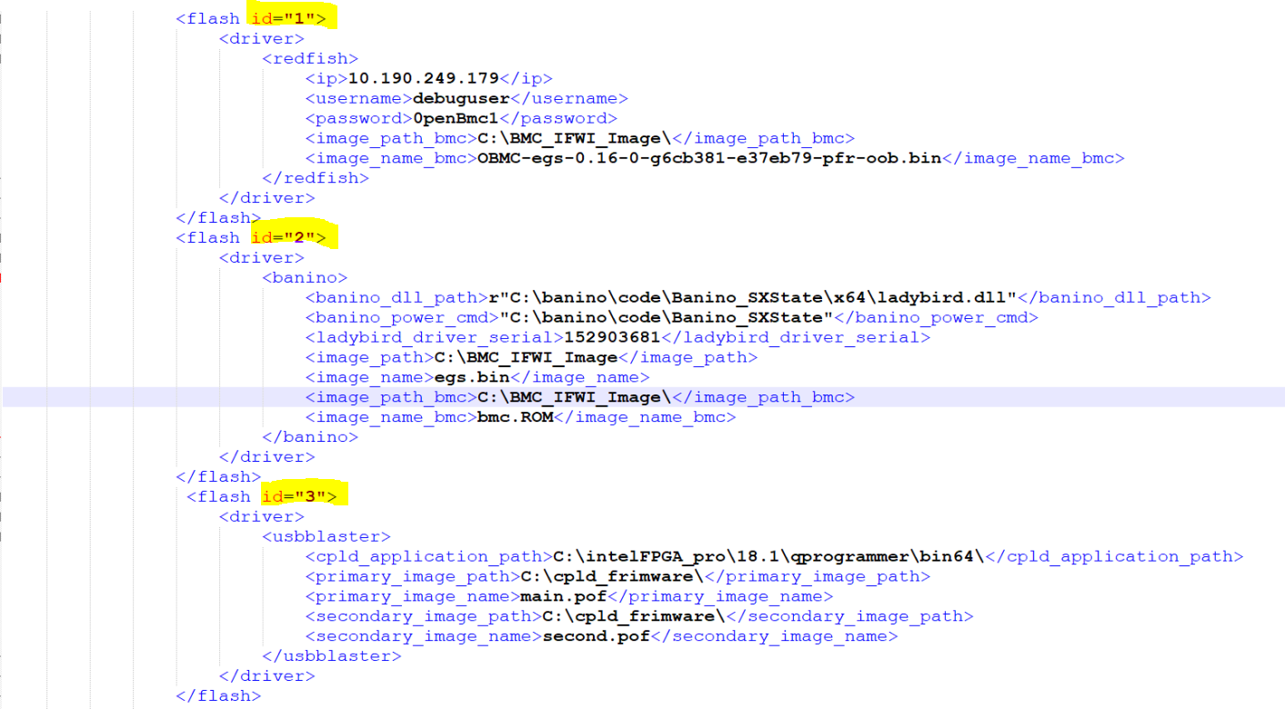

**Redfish:**

Below is the redfish configuration that should be copied to system_configuration.xml file before using the redfish flash provider.

<flash id="1">

<driver>

<redfish>

<ip>10.190.249.179</ip>

<username>debuguser</username>

<password>0penBmc1</password>

<image_path_bmc>C:\BMC_IFWI_Image\</image_path_bmc>

<image_name_bmc>OBMC-egs-0.16-0-g6cb381-e37eb79-pfroob.bin</image_name_bmc>

</redfish>

</driver>

</flash>

**Banino:**

Below is the Banino configuration that should be copied to system_configuration.xml file before using the banino flash provider.

<flash id="2">

<driver>

<banino>

<banino_dll_path>r"C:\banino\code\Banino_SXState\x64\ladybird.dll"</banino_dll_path>

<banino_power_cmd>"C:\banino\code\Banino_SXState"</banino_power_cmd>

<ladybird_driver_serial>152903681</ladybird_driver_serial>

<image_path>C:\BMC_IFWI_Image</image_path>

<image_name>egs.bin</image_name>

<image_path_bmc>C:\BMC_IFWI_Image\</image_path_bmc>

<image_name_bmc>bmc.ROM</image_name_bmc>

</banino>

</driver>

</flash>

**CPLD Flashing:**

Below is the cpld configuration that should be copied to system_configuration.xml file before using the cpld flash provider.

<flash id="3">

<driver>

<usbblaster>

<cpld_application_path>C:\intelFPGA_pro\18.1\qprogrammer\bin64\</cpld_application_path>

<primary_image_path>C:\cpld_frimware\</primary_image_path>

<primary_image_name>main.pof</primary_image_name>

<secondary_image_path>C:\cpld_frimware\</secondary_image_path>

<secondary_image_name>second.pof</secondary_image_name>

</usbblaster>

</driver>

</flash>